**E-commerce Website for Sporty Shoes**

**SportyShoes**

**Content:**

* Project and developer details
* Sprints planned and the tasks achieved in them
* Flowcharts of the application
* Core concepts used in the project
* Links to the GitHub repository to verify the project completion

**Project and developer details :**

Application is Developed by ***Vijay Moirangthem***

**Github Account: https://github.com/VijayMoirangthem**

| **Product backlog (User Story):** | **Story Points:** |
| --- | --- |
| There will be an admin to manage the website. An administrator login will be required to access the admin page. | 4 |
| Manage the products in the store including categorizing them | 3 |
| Browse the list of users who have signed up and be able to search users | 4 |
| See purchase reports filtered by date and category | 3 |
| Presenting the specification document which has the product’s capabilities, appearance, and user interactions | 3 |

**Sprints planned and the tasks achieved in them:**

We have planned our problem description into 5 product backlogs.

**We are planning to divide our user stories into 3 sprints:**

* Sprint 1:

Task 1: Analyzing the problem.

Task 2: Creating a flow chart.

Task 3: Implementing User Story 1

* Sprint 2:

Task 1: Implementing User Story 2.

Task 2: Implementing User Story 3.

* Sprint 3:

Task 1: Implementing User Story 4.

Task 2: Implementing User Story 5.

Time box per Sprint is 1 week.

* The velocity of the team is 17 story points/3 weeks=6.

There were 3 releases for each sprint

**Algorithms and flowcharts of the application**

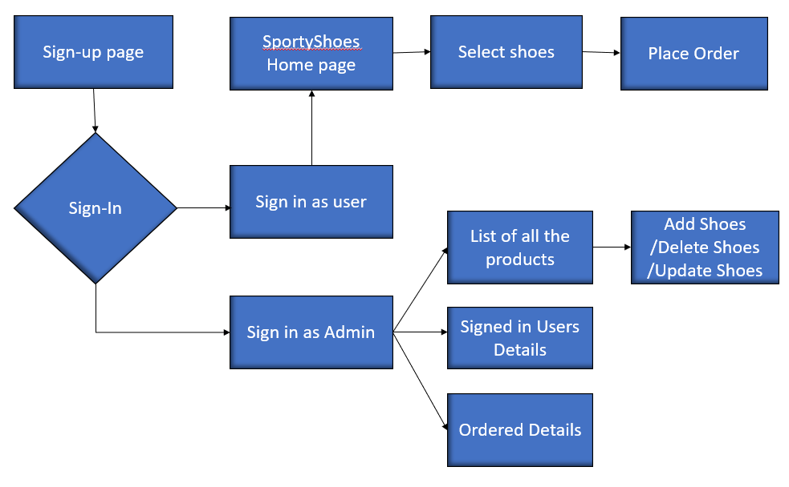

**Core concepts used in the project:**

**Implementation is done using:**

* MySQL workbench (for database)
* Exception handling
* Recursion
* Spring Boot

**Links to the GitHub repository to verify the project completion:**

**GitHub repo: *https://github.com/VijayMoirangthem/SportyShoes.git***